**Project Name: Taste of Kashmir Restaurant**

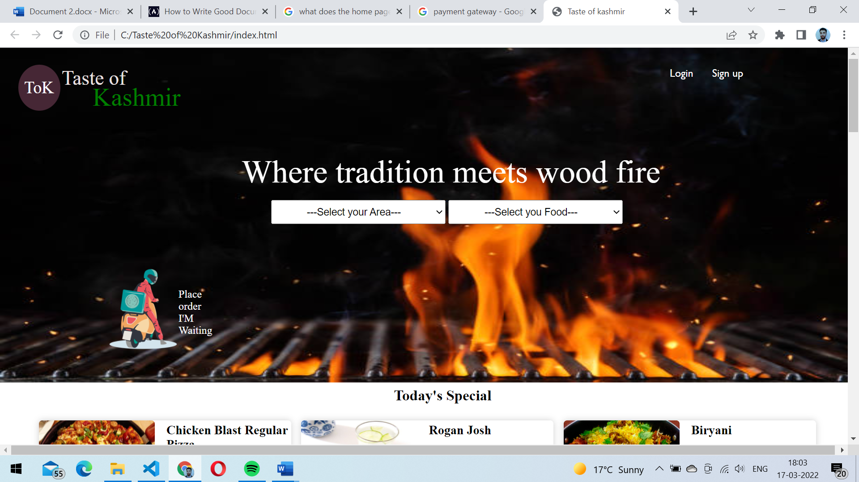

**Pages:**

* Login/Sign up page
* Home page
* Listing page
* Filter and search
* Detail page
* Buying Option
* Payment Gateway

**Page Structure:**

**Home page:** A homepage on a website is where you can get to other areas of the site.

**Login page:** Asks users to enter email and password.

**Listing page**: where the user can click the product(image) home page will redirect the user to that category.

**Detail Page:** Detail page shows all the related information.

**Buying Option:** Users have options Like (COD, Debit card, Credit card)

**Payment Gateway:** Allow users to pay.

**Basic Features:**

**Sign up:**

**Form:** Customers details as input

Name

Mobile Number

Email-id

Address

**Login:**

Email/username (*required)

Password (*required).

Forgot password

**Filter and search bar:**

**Footer**: (About us, Team, our services, contact us, privacy policy, terms and conditions, Refund and cancellation)